Procarbazine, Dacarbazine and Temozolomide:
Procarbazine is an antineoplastic agent was originally developed as a result of efforts to find new inhibitors of (MAO). Subsequent screening revealed anti-neoplastic activity.
It was initially believed that the cytotoxicity was related to the ability of cpd. to undergo auto-oxidation to give hydrogen peroxide, which in the presence of Fe(II) would produce hydroxide radicals capable of cleaving DNA. Subsequent work showed that although this did occur, sufficient amounts of hydrogen peroixde were not produced to account for observed effects.
From metabolism studies revealed that oxidation of Procarbazine does not occur in the liver and is mediated by CYP and MAO to give azo-procarbazine.This cpd may also be generated non-enzymatically in an aerobic environment.
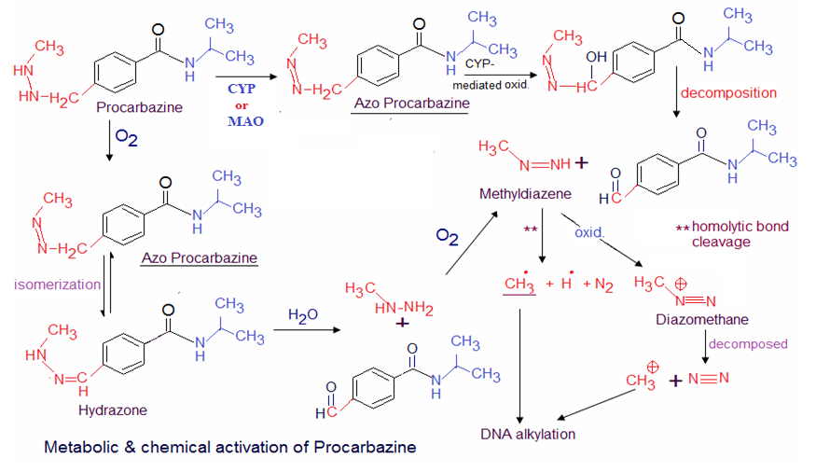
there are several chemical & metabolic pathways that azo-procarbazine may then undergo, and there is some disagreement regarding the exact structure of the active alkylating species.
By radiolabeled procarbazine studies found the terminal Me group was covalently bound to
N-7 position of guanine especially on tRNA distrupting its function & preventing protein,RNA and DNA synthesis.

Dacarbazine, which was initially thought to act as an inhibitor of purine biosynthesis, but later was shown to an alkylating agent.
Activation of the agent occurs through the action of CYP to give the demethylated product monomethyl triazeno imidazole carboxamide (MTIC).
Tautomerization allows for decomposition to give the aminocarboxamido-imidazole and diazomethane, which is capable of alkylating DNA.
An alternative pathway involves acid catalyzed or photoinduced loss of dimethylamino to give an alternative diazo compound (diazo- IC), which may not only generate a carbocation but also undergoes internal cyclization to give 2-azo-hypoxanthine.
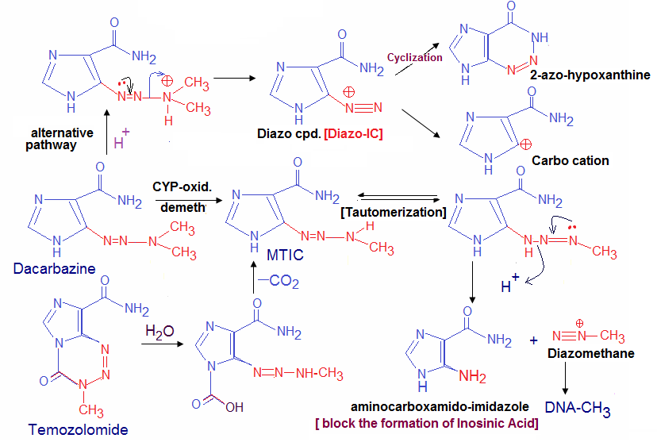
Formation of diazo-IC has been associated with pain at the injection site, which is often seen during dacarbazine administration.
Methylation of DNA occurs at N-7,N-3 and O-6 of guanine among other sites.
Dacarbazine proved to be more active against murine tumors than against human tumors. This was attributed to the enhanced ability of mice to metabolize the agent to MTIC & the subsequent conversion to a methylating species.
Building on this idea was development Temozolomide,
MTIC,as dacarbazine but it does not require metabolic activation to do so.
Hydrolysis of temozolomide gives the carboxy-triazene must be administrated I.V.

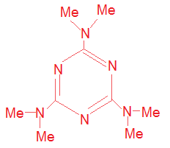
Altretamine (Hexalen,Hexamethylmelamine):
Is available as capsules for oral admin.
As a 2nd –line in treatment for ovarian cancer.
Cytotoxicity has been correlated with metabolism
to give the carbinolamines which may form imines
capable of cross-linking, or decompose to give formaldehyde, which may react with nucleophile on DNA or protein.
